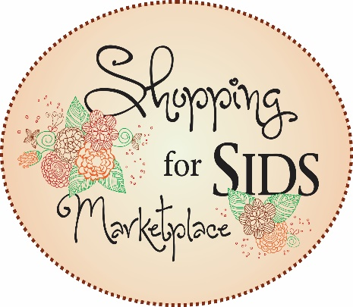
Exhibitor and Sponsor Contract

MS SIDS & Infant Safety Alliance, Inc.
Shopping for SIDS Marketplace
Saturday, October 20, 2018
9:00 A.M. until 3:00 P.M.

Please print or type:

Contact Name:___________________________________________________________

Company Name:__________________________________________________________

Address:________________________________________________________________

City, State, ZIP___________________________________________________________

Email:_______________________________________Phone______________________

This contract does hereby reserve an exhibit space for the above referenced company.

Authorized signature:______________________________________________________

Check all that apply:
Diamond Sponsor: $250.00 (includes signage for event and booth space) $___________

Refreshment Sponsor: $100 (includes signage for break and booth space) $__________

Exhibitor Fees:
Shopping for SIDS Exhibitor $50.00 (10’X 10’ space and chair) $___________

Subtotal $___________

TOTAL $___________

Return by Friday, October 5, 2018 with payment to:
MS SIDS & Infant Safety Alliance, PO BOX 2170, Madison, MS 39130
FAX (601) 957-7488

We look forward to seeing you this year at the 12th Annual
Shopping for SIDS Marketplace!

